COIT20247
Database Design and Development

Term – 1, 2020
Assignment-1

Lecturer/Tutor:
Annie Ding

Prepared By:
Bishal Budhathoki
12116421
Table of Contents:

Entity Relationship Diagram: 3
Assumptions/ Business Rules: 4
Data Dictionary: 5
Acknowledgment 13

Entity Relationship Diagram:
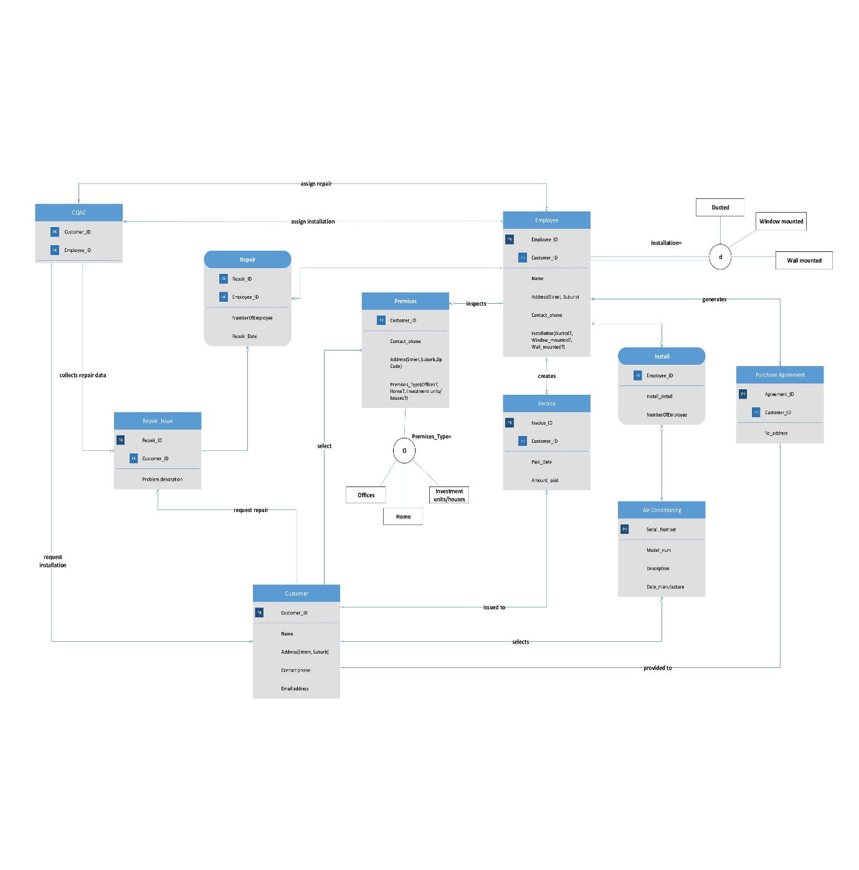

Note: Please zoom in the image for higher details.
The above provided image is the ER diagram representation of CQ Air conditioning services (CQAC).

Assumptions/ Business Rules:
From the case study of CQ Air conditioning services (CQAC), there are some assumptions made. They are listed below:
- Customer on the first hand will provide premises information to the company.
- Employee provide option of selecting the installation type to the customer after company assign the task to the employee.
- Every request of installation/repair needs to go through CQAC then it is passed to employee.
- One employee can visit multiple premises for inspection.
- From the case study, it is assumed that single employee is assigned for repair and zero or more employee is assigned for installation.
- No employee will perform repair or installation until assigned by CQAC.
- Customer always first communicates with CQAC then CQAC assigns task. Then either repair, or installing or both activities is done.
- Invoices are generated after finishing the repair or instalment.
- Purchase agreement is generated after product to install is selected by customer.
- Repair issue contains the issue which is then obtained by CQAC only.
- 40% of total amount is the minimum required balance to pay in the first invoice generated.
- Only one employee will generate invoice and purchase agreement.
- Only one employee will inspect the premises.
- Employee provide exactly one options for mounting.

Data Dictionary:

Entity name | Entity Definition | Attribute name | Attribute Definition | Data types | Length | Primary key | Nullable | Unique | Min/Max value
Employee | An employee is someone who work in CQAC | Employee_ID | For unique identification of employee records | integer | 10 | True | False | True | N/A
 |  | Customer_ID | For unique identification of customer records | integer | 10 | False | False | False | N/A
 |  | Name | Name of the employee | varchar | 255 | False | False | False | N/A
 |  | Street | Street for the address of employee | varchar | 255 | False | True | False | N/A
 |  | Suburb | Street for the address of employee | varchar | 255 | False | True | False | N/A
 |  | Contact phone | Phone number to contact of employee | number | 10 | False | True | False | N/A
 |  | Ducted | Type of installation | varchar | 5 | False | False | False | N/A
 |  | Window mounted | Type of installation | varchar | 5 | False | False | False | N/A
 |  | Wall mounted | Type of installation | varchar | 5 | False | False | False | N/A

Entity name | Entity Description | Column name | Column Description | Data types | Length | Primary key | Nullable | Unique | Min/Max value
CQAC | Name of company is CQAC | Employee_ID | For unique identification of employee records | integer | 10 | False | False | False | N/A
 |  | Customer_ID | For unique identification of customer records | integer | 10 | False | False | False | N/A

Entity name | Entity Description | Column name | Column Description | Data types | Length | Primary key | Nullable | Unique | Min/Max value
Repair_issue | Customer might request for repair of AC | Repair_ID | For unique identification of repair records | Integer | 10 | True | False | True | N/A
 |  | Customer_ID | For unique identification of customer records | integer | 10 | False | False | True | N/A
 |  | Problem description | For understanding the issue better | varchar | 255 | False | False | False | N/A

Entity name | Entity Description | Column name | Column Description | Data types | Length | Primary key | Nullable | Unique | Min/Max value
Invoice | Commercial document issued by CQAC to customer | Invoice_ID | For unique identification of invoice records | integer | 10 | True | False | True | N/A
 |  | Date paid | Full/ partial amount paid date | Date | 10 | False | False | False | N/A
 |  | Amount paid | Full / partial amount paid | Integer | 10 | False | True | False | >40% of total amount  <Full amount
 |  | Customer_ID | For unique identification of customer records | Integer | 10 | False | False | False | N/A
 |  | Repair_ID | For unique identification of repair records | Integer | 10 | False | True | False | N/A

Entity name | Entity Description | Column name | Column Description | Data types | Length | Primary key | Nullable | Unique | Min/Max value
Air Conditioning | AC that customer request | Serial_Number | For unique identification of AC records | integer | 10 | True | False | True | N/A
 |  | Model | Describes what it consists | integer | 10 | False | False | False | N/A
 |  | Description | Describes the model and features | varchar | 255 | False | True | False | N/A
 |  | Date_manufacture | Manufactured date of AC | Date | 10 | False | False | False | N/A

Entity name | Entity Description | Column name | Column Description | Data types | Length | Primary key | Nullable | Unique | Min/Max value
Purchase Agreement | Defines the purchase agreement | Agreement_ID | For unique identification of product purchased | Integer | 10 | True | False | True | N/A
 |  | Customer_ID | For unique identification of customer records | Integer | 10 | False | False | True | N/A
 |  | To_address | For address of delivery of product | Varchar | 255 | False | False | False | N/A

Entity name | Entity Description | Column name | Column Description | Data types | Length | Primary key | Nullable | Unique | Min/Max value
Customer | Defines the buyer or service user | Customer_ID | For unique identification of customer records | Integer | 10 | True | False | True | N/A
 |  | Name | Customer name | Varchar | 255 | False | False | False | N/A
 |  | Street | Street customer lives in | Varchar | 255 | False | False | False | N/A
 |  | Suburb | Suburb customer lives in | Varchar | 255 | False | False | False | N/A
 |  | Contact_phone | Customer phone number | Integer | 10 | False | False | False | N/A
 |  | Email address | Email address of customer | Varchar | 255 | False | False | False | N/A
 |  | Offices | Premises address option | Varchar | 255 | False | False | False | N/A
 |  | Home | Premises address option | Varchar | 255 | False | False | False | N/A
 |  | Investment units/houses | Premises address option | Varchar | 255 | False | False | False | N/A

Entity name | Entity Description | Column name | Column Description | Data types | Length | Primary key | Nullable | Unique | Min/Max value
Install | This describes installing AC activity (Associative) | Employee_ID | For unique identification of employee records | integer | 10 | False | False | True | N/A
 |  | Install_detail | Describes condition for installing | varchar | 255 | False | False | False | N/A
 |  | NumberOfEmployee | Describes number of employed | int | 10 | False | False | False | N/A

Entity name | Entity Description | Column name | Column Description | Data types | Length | Primary key | Nullable | Unique | Min/Max value
Repair | This describes repairing of AC activity (Associative) | Employee_ID | For unique identification of employee records | integer | 10 | False | False | True | N/A
 |  | Repair_ID | Describes condition for installing | integer | 10 | False | False | True | N/A
 |  | NumberOfEmployee | Describes number of employed | varchar | 10 | False | False | False | N/A
 |  | Repair_Date | Describes when repair will be done | integer | 10 | False | False | False | N/A

Entity name | Entity Definition | Attribute name | Attribute Definition | Data types | Length | Primary key | Nullable | Unique | Min/Max value
Premises | Describes where installation is required | Customer_ID | For unique identification of customer records | integer | 10 | False | False | True | N/A
 |  | Contact_phone | For unique identification of customer contact number | integer | 10 | False | False | False | N/A
 |  | Street | Street for the address of employee | varchar | 255 | False | True | False | N/A
 |  | Suburb | Street for the address of employee | varchar | 255 | False | True | False | N/A
 |  | ZipCode | Phone number to contact of employee | number | 10 | False | True | False | >0001  <9999
 |  | Offices | Type of premises | varchar | 255 | False | False | False | N/A
 |  | Home | Type of premises | varchar | 255 | False | False | False | N/A
 |  | Investment units/houses | Type of premises | varchar | 255 | False | False | False | N/A

Acknowledgment

This assignment was completed using only the COIT20247 unit materials and lecturer/ tutor Annie Ding help during tutorial classes. Various slides and text book material provided in moodle has been used for this assignment.

Bishal Budhathoki,
12116421

